Spectral coherence: EURUSD and NZDUSD
Method 21 / daily log returns / Welch magnitude-squared coherence / Alpari D1 full available history

Study setup
Logical pair: EURUSD , NZDUSD
Broker symbols: EURUSD_i , NZDUSD_i
Snapshot: 2026-11-03_majors_alpari_D1
Timeframe: D1
Matched return window: 1999-01-05 to 2026-11-02 (UTC bar dates)
Matched return count n: 7186
Dropped unfinished last bar dated 2026-11-03 UTC after a tick-volume check against the prior complete day.
Welch: fs=1.0, nperseg=256, noverlap=128, window=hann, detrend=constant
Headline: gamma^2 nearest f=1/5; also 1/21 and 1/63
Complete matched rows (Excel): EURUSD-NZDUSD_Spectral_D1.xlsx
Complete matched rows (HTML table): EURUSD-NZDUSD_Spectral_D1_data.html

Method carried forward
Magnitude-squared spectral coherence gamma^2(f) measures shared linear power between matched daily log returns of close, ln(close_t / close_t-1), at each frequency f (cycles per day). Quotes are not inverted. Welch settings are frozen: fs=1, nperseg=256, noverlap=128, window=hann, detrend=constant. Headline is gamma^2 at the frequency bin nearest f=1/5 (five-day cycle from the formula sheet). Also reported: gamma^2 nearest f=1/21 and f=1/63, mean gamma^2 over the frequency grid, and phase of the cross-spectrum at the 1/5 bin. Coherence is unsigned (0 to 1); phase carries timing. Same-sample Pearson r is a side check only. This is not causation and not a trading signal.

Results (headline)
gamma^2 near 1/5: 0.446199
bin f (1/5): 0.199219
phase at 1/5 (rad): 0.022085
gamma^2 near 1/21: 0.263873
gamma^2 near 1/63: 0.463681
mean gamma^2: 0.327776
Pearson r: 0.549808

Target-frequency summary
period | target_f | f_bin | gamma2 | phase_rad
5 | 0.2 | 0.19921875 | 0.44619854 | 0.02208538
21 | 0.04761905 | 0.046875 | 0.26387306 | 0.11705053
63 | 0.01587302 | 0.015625 | 0.46368073 | -0.16859244

Conclusion
Headline gamma^2 near f=1/5 for EURUSD and NZDUSD: 0.4462 (bin f=0.199219, phase=0.0221 rad). At ~1/21: 0.2639; at ~1/63: 0.4637. Mean gamma^2 = 0.3278. Pearson r = 0.5498. This is frequency-domain linkage, not a trading signal.

Charts
Daily closes

Daily log returns

Spectral coherence gamma^2(f)
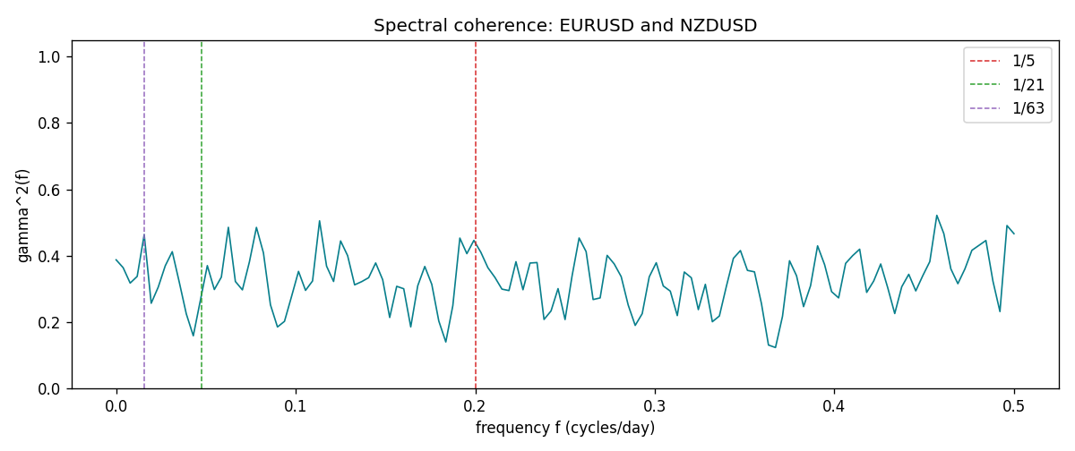

Data report
Matched rows and the coherence sheet are in the sibling Excel workbook named EURUSD-NZDUSD_Spectral_D1.xlsx. Embedding all rows as a Word table is impractical; this file holds column summaries and the first and last 15 matched rows.
Columns: time, EURUSD_open, NZDUSD_open, EURUSD_high, NZDUSD_high, EURUSD_low, NZDUSD_low, EURUSD_close, NZDUSD_close, EURUSD_tick_volume, NZDUSD_tick_volume, EURUSD_spread, NZDUSD_spread, EURUSD_real_volume, NZDUSD_real_volume, EURUSD_log_return, NZDUSD_log_return
Column summaries (matched calculation rows)
column | count | mean | std | min | 25% | 50% | 75% | max
EURUSD_open | 7186 | 1.181357 | 0.15085833 | 0.8272 | 1.086165 | 1.16609 | 1.2939475 | 1.5995
NZDUSD_open | 7186 | 0.65641776 | 0.10819833 | 0.3913 | 0.59134 | 0.6684 | 0.7249075 | 0.88218
EURUSD_high | 7186 | 1.1864878 | 0.15145386 | 0.8326 | 1.09024 | 1.17121 | 1.2993075 | 1.6038
NZDUSD_high | 7186 | 0.66033433 | 0.10869188 | 0.3961 | 0.59475 | 0.67202 | 0.72936 | 0.88421
EURUSD_low | 7186 | 1.1763494 | 0.15017707 | 0.8227 | 1.082045 | 1.162475 | 1.2884175 | 1.5865
NZDUSD_low | 7186 | 0.65273031 | 0.10779283 | 0.3897 | 0.5880725 | 0.664185 | 0.720965 | 0.87988
EURUSD_close | 7186 | 1.1813978 | 0.15082738 | 0.8267 | 1.0860425 | 1.16602 | 1.2939725 | 1.5997
NZDUSD_close | 7186 | 0.65649194 | 0.10819527 | 0.3907 | 0.59159 | 0.66842 | 0.725015 | 0.8822
EURUSD_tick_volume | 7186 | 103205.25 | 173535.32 | 218 | 9413.25 | 52774.5 | 99579.75 | 1471626
NZDUSD_tick_volume | 7186 | 68709.014 | 123134.25 | 16 | 5585.5 | 33893.5 | 58510.5 | 1127682
EURUSD_spread | 7186 | 19.350682 | 16.562781 | 0 | 8 | 12 | 27.5 | 50
NZDUSD_spread | 7186 | 30.284303 | 25.649992 | 0 | 9 | 17 | 47.5 | 80
EURUSD_real_volume | 7186 | 4.0330482e+10 | 1.6691688e+11 | 0 | 0 | 0 | 0 | 3.6149665e+12
NZDUSD_real_volume | 7186 | 1.6701379e+10 | 8.497804e+10 | 0 | 0 | 0 | 0 | 2.705649e+12
EURUSD_log_return | 7186 | -4.99e-06 | 0.00579654 | -0.03123819 | -0.00323792 | 0 | 0.00325328 | 0.03433183
NZDUSD_log_return | 7186 | 9.3e-06 | 0.0076423 | -0.07027433 | -0.00425367 | 0.00022883 | 0.00457975 | 0.05966839
First 15 matched rows (selected columns)
time | EURUSD_log_return | NZDUSD_log_return
1999-01-05 | -0.0048360507 | -0.0018597736
1999-01-06 | -0.011547966 | 0.0020455609
1999-01-07 | 0.0076280636 | 0.0062963171
1999-01-08 | -0.010902799 | -0.00055396548
1999-01-11 | -0.007103287 | 0.010290425
1999-01-12 | 0.0045103728 | -0.0053157489
1999-01-13 | 0.010845346 | -0.0099742238
1999-01-14 | 0 | -0.00018564931
1999-01-15 | -0.010153245 | -0.00074294208
1999-01-18 | 0.0036256946 | -0.0018597736
1999-01-19 | -0.00017235436 | 0.0018597736
1999-01-20 | -0.0031939256 | 0.0040793678
1999-01-21 | 0.0030215416 | 0.0040627941
1999-01-22 | -0.0012075213 | -0.012051689
1999-01-25 | -0.0030251979 | -0.0035504102
Last 15 matched rows (selected columns)
time | EURUSD_log_return | NZDUSD_log_return
2026-10-13 | 0.0037402957 | 0.0047326165
2026-10-14 | -0.0037582255 | -0.0037306483
2026-10-15 | 0.0056053107 | 0.0047634855
2026-10-16 | 0.0017724895 | 0.0057501001
2026-10-19 | -0.0025394633 | 0.0018917133
2026-10-20 | 0.0023881672 | 0.0037199341
2026-10-21 | -0.00032046717 | 0.0030923331
2026-10-22 | -0.0015949606 | -0.0033035227
2026-10-23 | -0.001338521 | 0.0030929853
2026-10-26 | -0.0022706559 | -0.0028993932
2026-10-27 | -0.004152342 | -0.00026399852
2026-10-28 | 0.0022262927 | -0.0097283914
2026-10-29 | 0.0022571351 | 0.00062190714
2026-10-30 | -0.0011458446 | 0.00019537668
2026-11-02 | 0.002120569 | -0.0025962955
First 15 frequency bins
f | gamma2 | phase_rad | period_days
0 | 0.38762701 | 0 | inf
0.00390625 | 0.36396032 | 0.00454035 | 256
0.0078125 | 0.31753834 | 0.12196389 | 128
0.01171875 | 0.33768654 | -0.01333403 | 85.333333
0.015625 | 0.46368073 | -0.16859244 | 64
0.01953125 | 0.25675599 | -0.17574769 | 51.2
0.0234375 | 0.3053516 | -0.27342492 | 42.666667
0.02734375 | 0.36953233 | -0.20419217 | 36.571429
0.03125 | 0.41215764 | -0.16986069 | 32
0.03515625 | 0.32026557 | -0.21930857 | 28.444444
0.0390625 | 0.2248918 | -0.0222061 | 25.6
0.04296875 | 0.15865831 | -0.07491609 | 23.272727
0.046875 | 0.26387306 | 0.11705053 | 21.333333
0.05078125 | 0.37019264 | 0.26792205 | 19.692308
0.0546875 | 0.29809949 | -0.01536408 | 18.285714

